Advanced Analytics in the NHL
Senior Exploration Project

Zander Lustig
June 2021
- Introduction
Hockey is a fast, multidimensional, and complex game. It cannot be looked at in a one-versus-one matchup like a batter and a pitcher in baseball, rather the whole team of five skaters and a goalie must be looked at as one cohesive unit, going against another team with proper formation and strategy. This lesser focus on the individual, along with the fact that the NHL’s revenue is lower than that of other major sports (There were no NHL teams featured in the top 50 most valuable franchises), means that analytics in the NHL is not nearly as developed as it is in other sports like baseball and basketball. With that being said, there is no shortage of statistics that have been created by the creative minds of NHL executives and hardcore fans. These statistics improve on the basic, “counting” statistics such as “Goals”, “Assists”, and “Plus-Minus”. Some of the more modern statistics are more “theoretical”, based on probabilities derived from large datasets. This means that these statistics cannot be applied to earlier eras of the game, as many of the building blocks to derive the statistics use data that previously wasn’t captured/tracked, not allowing comparisons to the greatest players in the history of the sport.
Many of the newer statistical constructs stem from shot tracking technology to determine the probability of a shot resulting in a goal, and this system has only been available in the NHL since the 2007-2008 season. Advanced analytics seem to have become an integral part of the NHL landscape in the evaluation of skaters and goalies, and the future of these statistics looks bright.

- Traditional Statistics
- Points
The area of information that should be the first thing looked at when evaluating a player are standard statistics like goals, assists, and points. They are just the most easily accessible of all hockey statistics and on a surface level, they will definitely show the best players in a certain timeframe. Here are the top leaders in points for both forwards and defensemen over the past five seasons:
Forwards: Defensemen:
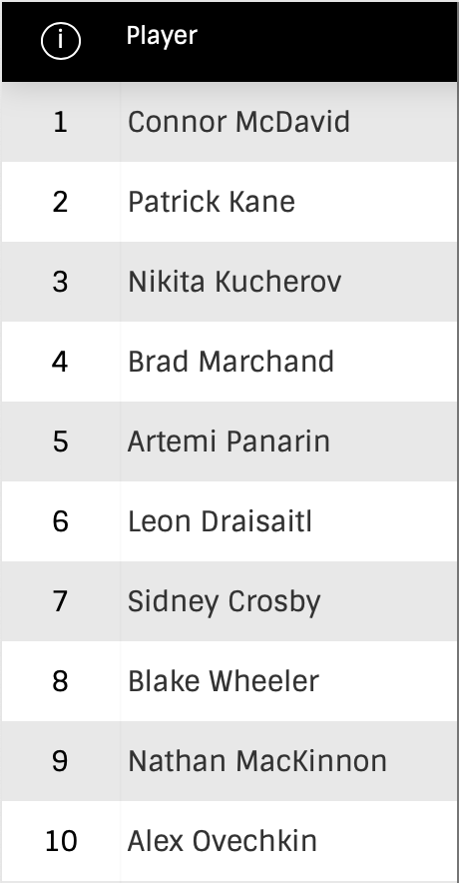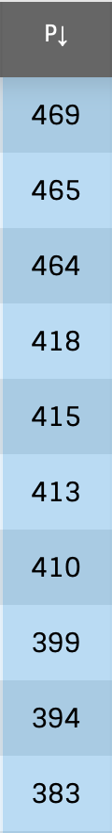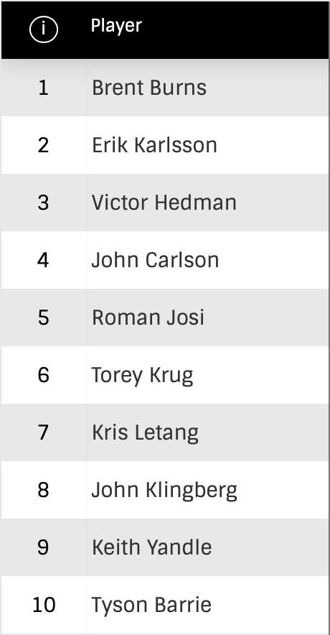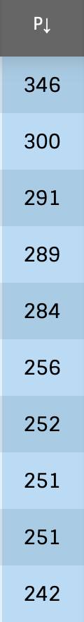
Most of the biggest names in hockey can be seen on the forward list, ranging from young stars, Connor McDavid and Nathan MacKinnon, to future Hall of Famers, Sidney Crosby and Alex Ovechkin. The list of defensemen is a little less varied, with every player coming in above the age of twenty-eight, and most, aside from three or four of them, being almost totally out of their prime.
This is what makes points an uneven indicator of impact, specifically for defensemen and forwards who show their worth in the defensive zone. Some of the best defensive defensemen in the league, like Adam Pelech of the Islanders or Jonas Brodin of the Wild, often get overlooked because they are not highly ranked using any of the most mainstream statistics. If points cannot account for these particular players, is there a statistic that can?

- Plus-Minus
Plus-Minus is a statistic that awards a skater a +1 if they were on the ice for a goal scored, and a -1 if they were on the ice for a goal against. It was created in the 1950s by a Montreal Canadiens franchise that was absolutely shredding the league, winning the Stanley Cup five consecutive times, from 1956-1960, en route to being known as one of the greatest dynasties in all of sports. They created plus-minus as a way to evaluate a player's impact on both ends of the rink, under the philosophy that a player’s presence on the ice when your team scores is just as helpful as them on the ice when the other team scores is unhelpful. This makes a lot of sense in theory, but is very unreliable in practice, as a player’s plus-minus can fluctuate very greatly from season to season. For instance, Alex Ovechkin, widely regarded as the greatest scorer in the history of the game, would be expected to have a solid plus-minus every season, but he has been a minus player five times in his 16 year career, even being a -35 in the 2013-14 season in which he led the league with 51 goals. How is this possible? A logical assumption is that he was especially terrible on defense that season and while “The Great 8” has never been great on defense, that particular year was no different from the next in which he scored 53 goals and was a +10.
This statistic as a whole is inherently flawed due to how team reliant it is. For example, a team’s goalie can let in shots that should’ve easily been saved, which would bring down a particular player’s plus-minus considerably as a result. Another example of scenarios that are out of some player’s control may be seen in the video below:
https://youtu.be/LXmBfqI6u6g
In the clip, the Senators receive a delayed penalty, allowing the Stars to pull their goalie for an extra skater; however, this all goes awry as an errant backpass from Jiri Hudler goes between the defensemen and into their own net. All Stars players on the ice were given a -1 on this play, but did they all really deserve it? What about the forwards who were already up the ice, with no way of intercepting Hudler’s pass? The point is that while plus-minus is a simple and conceptually brilliant statistic, it is not a reliable indicator of defense or offense and should not be seriously looked at when evaluating a certain player’s impact.

- Better Alternatives for Standard Statistics
- Primary Points
“Primary Points” are a much better indicator of offensive playmaking than simply just looking at points. The difference is that primary points only take goals and “primary assists” (A1) into account, meaning that “secondary assists” (A2) are thrown out the window. The reasoning behind why these secondary assists are less important is that they don’t always mean that someone contributed to the play. Assists can be deceiving, as seen on this incredible goal by Connor McDavid:
https://youtu.be/gcfIqClMstY
In the clip, he gets the puck in his own zone from Tyson Barrie, and McDavid proceeds to dance around the Maple Leafs defenders en route to one of the best goals of the season. Barrie does indeed get an assist on this play, but did he really do anything to contribute? Not really, as all he does is dump the puck off to the most skilled player the game has ever seen - any player would do what Barrie did in that specific scenario.
This is where primary points come into play, in scenarios where the secondary assist is a simple pass out of the defensive zone or handoff to another player (i.e., plays that don’t require much skill/playmaking). Using the equation primary points/points, teams are able to figure out which player’s point totals are truly elite and whose are not.

- Corsi and Fenwick
“Corsi” has become a hot topic in the hockey community these past few years and has been entangled with the term “hockey analytics” ever since it was created. To “analytics deniers” (players, coaches, and fans included), Corsi has become the poster child for most of the backlash relating to advanced analytics. Not bad for a statistic named after a coach simply because he had a cool mustache. Corsi has become the most mainstream of all hockey analytics, even though many don’t even know what it refers to.
Corsi is a statistic that measures shot totals. It adds up all the shot attempts for, and subtracts them by the shot attempts against, giving a +1 to player when their team records a shot while they’re on the ice, and a -1 when their team records a shot against. Sound familiar? Corsi is meant to be a direct replacement for plus-minus. It has shown to be much more effective than plus-minus at predicting the future success of players and teams. Another named statistic, “Fenwick”, is similar to Corsi in that it is meant to use shots to predict which teams are controlling play, but it is slightly different in that it doesn’t include blocked shots. An adjustment of Corsi and Fenwick, “Corsi For %” and “Fenwick For %”, shows the percentage of shots in a game that a certain team is shooting over their opponent. In other words, if a team has a Corsi For % of 55%, they are taking an average of 55% of the shots in their games, while their opponents are taking 45%. Here are the top 14 teams in terms of Corsi For % and Fenwick For % from the last full season in the NHL (2018-19):
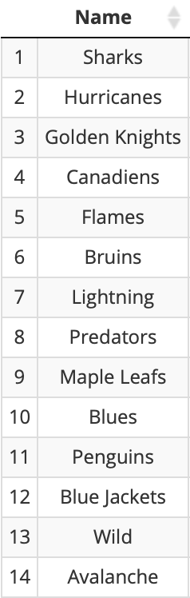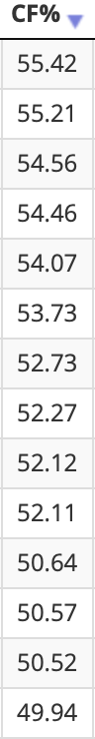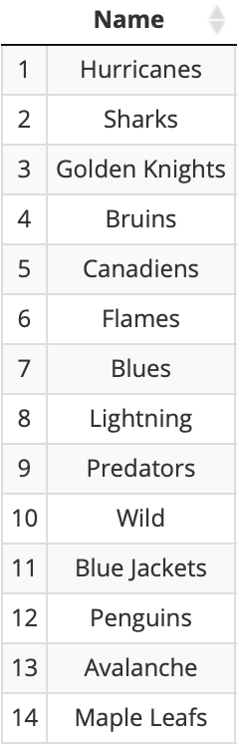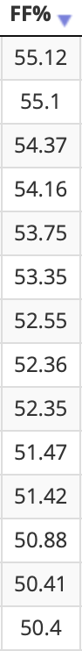
The trend here is that 12 out of the top 14 teams in both categories from that season made the playoffs, with one of the teams that didn’t, the Canadiens, only being unable to make it due to their uncommonly strong conference. While outshooting your opponent doesn’t guarantee scoring goals and wins, it does give your team the best chance to win, and as seen here, it very often translates to playoff appearances and success.

- Advanced Ways of Finding Offensive and Defensive impact
- Goals For and Goals Against
“Goals For” (GF) and “Goals Against” (GA) might seem like simple terms on the surface, but these are not simply referring to physical goals scored and allowed. They adjust in regards to score, opponents, teammates, and even venue to come up with a statistic that can show the offensive or defensive impact a certain player has. Take Jared McCann of the Pittsburgh Penguins from this past season (2020-21) as an example: In terms of GF per 60 minutes, he was second only to Connor McDavid and yet, he had just 32 points this season, good for 5th on his team and tied for 119th in the NHL - not so flattering. So what does this mean? How does someone get put in the same conversation as McDavid in one offensive statistic, yet mediocre in another? The answer is simply that McCann generated chances at an extremely high rate this season, one that would almost certainly regress in a longer season, and it showed on his GF total.
Goals Against is a similar calculation, just in the other direction (using Corsi Against and Fenwick Against). In order to read the statistic, players with a negative GA are the ones having good defensive seasons. Here are the top 20 forwards in terms of RAPM adjusted GA from the 2020-21 season:
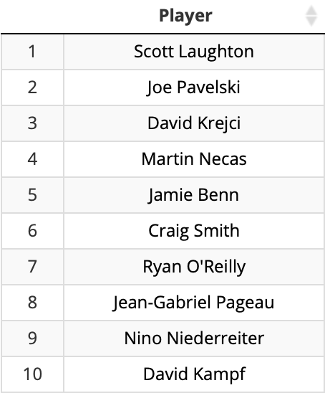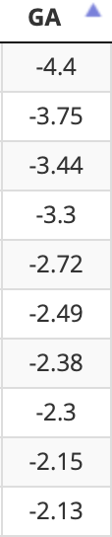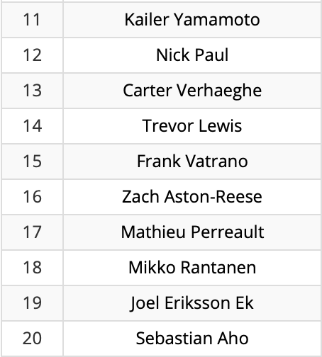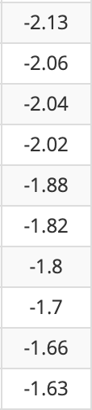
When looking at the top of the GA list, there are some lesser-known names, but there are also very familiar two-way forwards, like Joe Pavelski, David Krejci, and Ryan O’Reilly. Further down the list, however, a trend begins to emerge - every single player, except for Pavelski and Kampf, is on a playoff team, and almost all playoff teams have one thing in common: a good goaltender. One could say that those players got their team to the playoffs through good defensive play, but as evident with Connor McDavid, one player cannot carry their team to the playoffs. The real solution to this observation is that GA is too dependent on a team’s goaltender. Players and more specifically, forwards, on teams with good goalies generally have a higher GA simply because their goalie saves more shots. That is where “Expected Goals”, and more specifically “Expected Goals Against”, comes into play.

- Expected Goals For and Expected Goals Against
“Expected Goals” (xG) are the newest branch of hockey analytics and consequently the most accurate of them all in terms of player and team evaluation. In order to calculate a player or team’s xG, they first must tap into past data about shot probability. xG is a statistic that has nothing to do with physical game events, as in, when someone takes a shot, it doesn’t matter whether it goes in or not - the only thing that gets added to xG is the fact that he shot it from a certain distance, angle, and timeframe, among other factors. Since the actions of goalies are taken completely out of the equation, “Expected Goals For” (xGF) and Against (xGA) are touted as more accurate than statistics based solely on scoring.
While GF is still a usable statistic, GA is not the most accurate due to the presence of goaltenders. Since xGA completely takes goalies out of the picture, it can be used as a more accurate measure of defense. When looking at the top 20 forwards in terms of RAPM adjusted xGA from this season, the list looks slightly different:
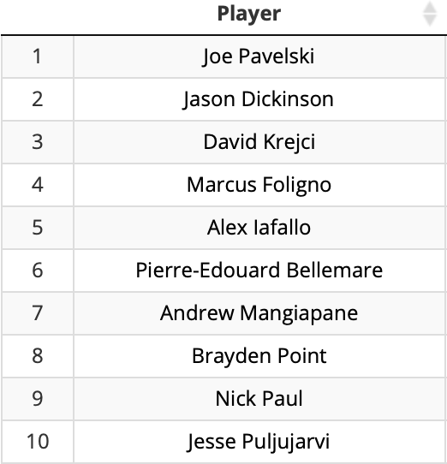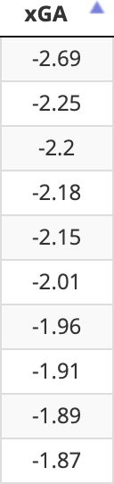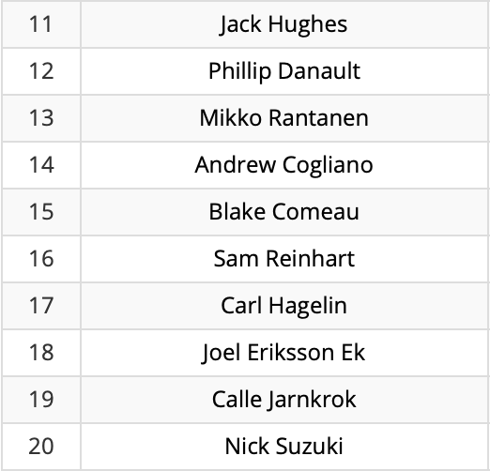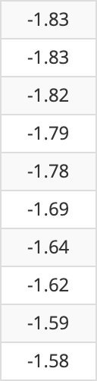
This list looks much different from the original Goals Against list, with many more players from non-playoff teams being featured. Some of the games biggest stars are featured on this list as well, from clutch, reigning Stanley Cup champion Brayden Point to former first-overall pick Jack Hughes. By removing the somewhat randomness of goaltenders, Expected Goals, while not perfect, give a fairly accurate representation of a player’s impact on the ice.

- Expected Goals - How can the casual fan apply it to real-time games?
During my research, I had an idea to allow every fan to try and “score” a game of hockey, similar to what is done at a baseball game. I devised a system where I would mark down how dangerous each shot attempt was in a certain game and come up with a total expected goals for each team. I then compared those totals to the actual expected goals to see how close I actually got. Here are the results of Game 5 of the second round matchup between the Boston Bruins and the New York Islanders:
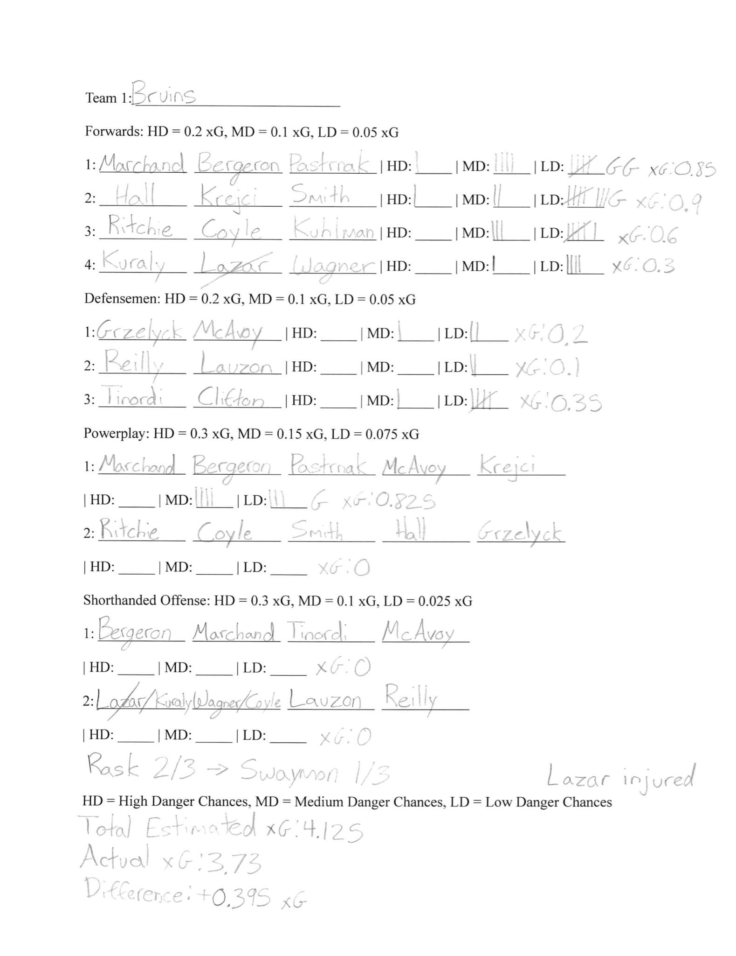
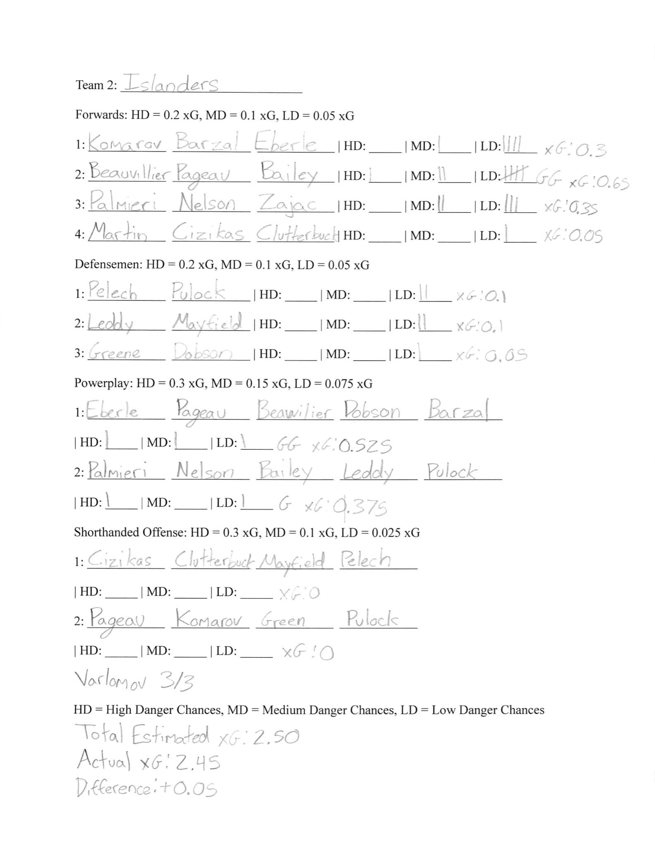
Using my scoring system, which I tried to make as simple as possible, and with my knowledge about how xG are calculated, I was only 0.395 xG off from the Bruins actual total and only 0.05(!) xG away from the Islanders true tally. So how did I get such accurate results? Honestly, I have no idea, and it was likely random luck. My goal was to get at least within 0.5 xG and I’m shocked it even passed that barrier.
The final score of the game was 5-4 with the Islanders taking home the win. With an expected goals of 2.45 and with the Bruins expected to score 3.73, The Islanders should consider themselves lucky that they were able to score that many goals, let alone win. The real difference maker in this game was goaltending. Semyon Varlomov of the Islanders played at a relatively average level, allowing 0.27 more goals than he was expected to, but Tuukka Rask allowed a whopping 1.96 more goals than he was expected to, and was therefore replaced to start the 3rd period, but by that time the damage was done.

- The Presence of Analytics in the NHL at an Executive Level
Analytics are not yet a high priority for NHL teams when they’re planning how to spend their budget. With that being said, they still have a very important (yet limited) role in terms of player evaluation, team strategy, and the monitoring of the salary cap. Every team can decide how many people they want to devote to their analytics department, and the average is about 3 people, ranging from the Ducks, Oilers, and Red Wings, with 1, to the Maple Leafs, with 8. This list has been growing much more rapidly in the most recent years, as more and more teams find value in using advanced analytics. Many of the top teams in the league are rumored to be built almost all around analytics, with some being the reigning champion Tampa Bay Lightning, the Presidents Trophy winning Colorado Avalanche, and the up-and-coming Carolina Hurricanes. Every single team (that uses analytics) has their own way of calculating all of the previously mentioned statistics and they each have their own set of results, which they think are more useful and accurate than that of other teams. The analytics landscape in the NHL is ever-changing, and teams will always try to get ahead in any way possible.

- Conclusion
Many of the writers on NHL.com and commentators of the live games seem to have trouble with analytics. It might be because it’s a fairly new concept, or they are traditionalists of the game, or maybe they simply don’t understand them. In my opinion, that third option is what I think is the biggest problem among current analysts. The lack of knowledge and research is what’s causing the lack of media coverage, popularity, and praise that analytics should be receiving. The biggest perpetrator (in my humble opinion) in this area is NBC analyst Pierre McGuire. During a Penguins playoff game earlier this year, he said, “the fourth line of the Penguins is one of the best in the league, now that’s something analytics can’t show you!” The fact of the matter is, however, that analytics can show you exactly that fact, and also show why they are. Analytics aren’t for everyone, as evident by the many analysts who reject it, but they will be an integral part of the game in the upcoming years, so a strong recommendation would be to start looking at them sooner rather than later.

- Bibliography
Awad, Tom, et al. Stat Shot: The Ultimate Guide to Hockey Analytics. ReadHowYouWant.com, Limited, 2016.
Baker, Christopher, and Stephen Shea. Hockey Analytics: A Game-Changing Perspective. Createspace Independent Publishing Platform, 2017.
Tanner, Peter. “MoneyPuck.com.” MoneyPuck.com -NHL Analytics, Playoff Odds, Power Rankings, Player Stats, 2015, https://moneypuck.com. Accessed 9 June 2021.
Timmins, Brad. “Natural Stat Trick.” Natural Stat Trick, https://www.naturalstattrick.com. Accessed 9 June 2021.
Ventura, Sam. Personal Interview. 13 May 2021.
Younggren, Josh, and Luke Younggren. “Evolving-Hockey.” Evolving-Hockey, 2018, https://evolving-hockey.com. Accessed 9 June 2021.

https://www.forbes.com/sites/mikeozanian/2021/05/07/worlds-most-valuable-sports-teams-2021/?sh=269dd6323e9e
NHL.com Points Leaderboard
Who just so happens to lead the league in A2...maybe because he plays with the 2 highest point getters in the league!
McDavid’s primary point percentage is a very solid 79%, while Barrie sports a paltry 44%.
The Real Story of How Corsi Got its Name
This includes shots on goal, shots that miss the net, and blocked shots.
Evolving-Hockey CF% and FF% Leaders (Teams)
He’s being mentioned a lot, but he really is too good not to!
Evolving-Hockey RAPM GA Leaders
There he is again!
Evolving-Hockey RAPM xGA Leaders
Regularized Adjusted Plus-Minus or RAPM adjusts all other statistics based on score, teammates, opponents, and venue, among other things.
A cool fact about Hughes is that he was the first ever Jew to be drafted first overall in any major professional sport!
All xG data is from MoneyPuck.com.
As of May 12, 2021.
Remember Jared McCann from the GF section and how he’s in the same conversation as Connor McDavid? Yes, he was part of that Penguins fourth line for most of the season!
Goal: When the puck passes over the line in the net and a tally is added to the scoring team. Assist: The act of passing it to the player who scored the Goal. Points: Goals + Assists.

